Eye aspect ratio

Each eye is represented by a 6 (x, y) coordinates. Starting at the left corner of the eye. By the image a key point to be taken here is the width and the height of these coordinates. (Cech, 2016). The NUMERATOR calculates the vertical distances between the landmarks and the DENOMINATOR calculates the horizontal distances between the landmarks.

EYE BLINK HAPPENS WHEN AND HOW?

***EYE ASPECT RATIO IS CONSTANT WHEN OPEN***

**Normally its 0.3 and above**

***WHEN BLINKING THE EYE ASPECT RATIO RAPIDLY FALLS TO 0***

This is when an eye blink is calculated.

In this case:

The eye aspect ratio is always 0.3 and up. But when blinked it will reach 0. Or less than 0.2. We calculate every frame here. Let us say the eye was blinked it reaches 0 and when it returns to 0.3 and up. Almost 3 frames have been recognized as less than 0.2. Which means the eye was closed.

Therefore the total eye blink is calculated.

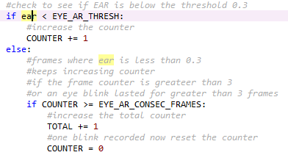

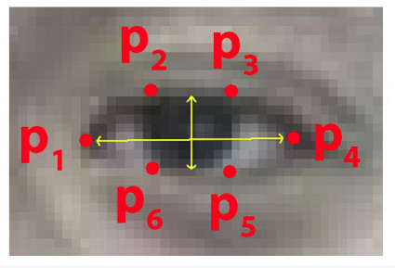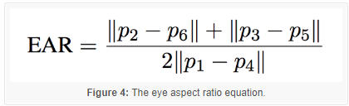

Calculate EAR method

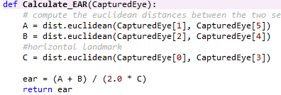

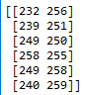

Landmark detection

For landmark detection we need the Dlib. The landmark detector gets all the facial coordinates in a 68 by 2 two dimensional array. The indexes for each facial feature can be found from the dictionary hence the import.

The Dlib landmark predictor is used to estimate the location of 68 (x, y) coordinates. That map the facial structures of the face. This is a trained data set.

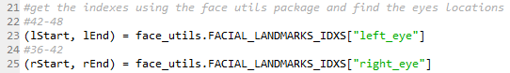



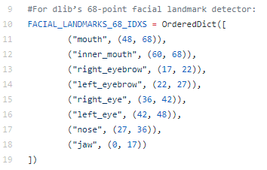

Face Shape to Coordinates detection

The landmark detector returns a shape object with 68 coordinates of the facial features. Converting it into a NumPy array over this method

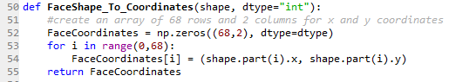

Face Eye Smile detect

This method detects the face, eye and smile using haar cascades. We used detect multiscale method to detect the face. We receive 4 coordinates as a rectangle. Display that face is detected. Draw a rectangle over the face

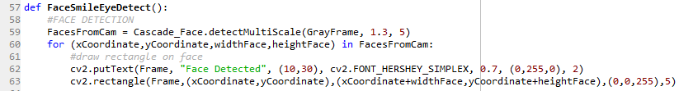

Now we do not need to scan the whole face again therefore we set the region of interest. We need a gray frame for detection and a normal frame to draw the output in.



Now we detect eyes Which is also similar to detecting the face

